MERN Stack Assignment Ans
Module 1 – SE -Overview of IT Industry
- Explain in your own words what a program is and how it functions.
Ans:- A program is a set of instructions written in a programming language that tells a computer what to do. It is created to solve a problem or perform a specific task, such as calculating numbers, displaying information, or controlling a device.
LAB EXERCISE: Write a simple "Hello World" program in two different programming languages of your choice. Compare the structure and syntax.
Output:- 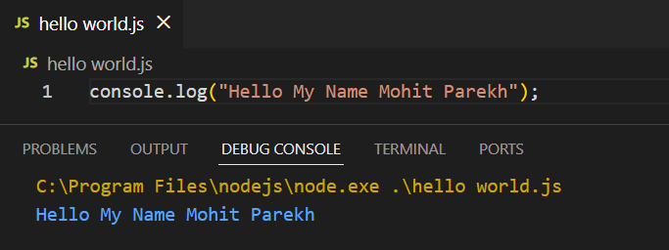
- What are the key steps involved in the programming process?
Ans:- 1.Problem Understanding – Clearly understand what problem needs to be solved.
2. Planning / Algorithm Design – Decide the steps or logic to solve the problem.
- Coding – Write the program using a programming language.
- Compilation / Execution – Convert the code into machine-readable form and run it.
- Testing & Debugging – Find and fix errors in the program.
- Maintenance – Update or improve the program after deployment.
3. What are the main differences between high-level and low-level programming languages?
Ans:-
High-Level Languages | Low-Level Languages
Easy for humans to read and write | Difficult for humans to read and write
Closer to English language | Closer to machine language
Machine-independent | Machine-dependent
Easy to debug and maintain | Hard to debug and maintain
Examples: Python, Java, C++ | Examples:-Assembly,Machine Language

LAB EXERCISE: -Research and create a diagram of how data is transmitted from a client to a server over the internet.
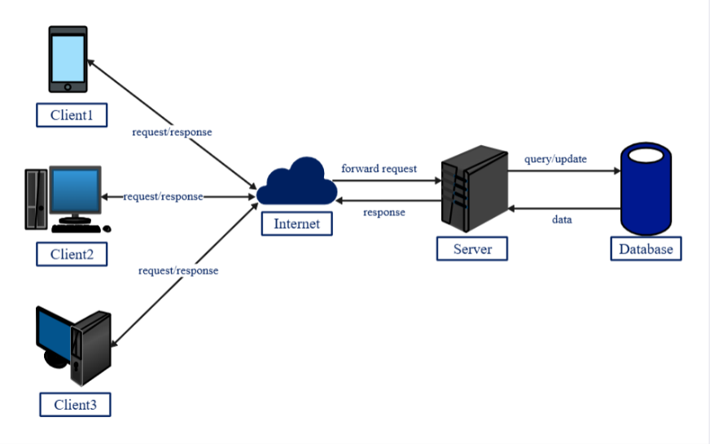
Client–Server Data Transmission Diagram
4. Describe the roles of the client and server in web communication.
- Client:
The client is usually a web browser or mobile app used by the user. It sends requests to the server, such as asking for a web page or data, and displays the response received from the server.
- Server:
The server is a powerful computer that stores websites, databases, and applications. It processes client requests, performs required operations, and sends the requested data or web pages back to the client.
LAB EXERCISE: Design a simple HTTP client-server communication in any language.
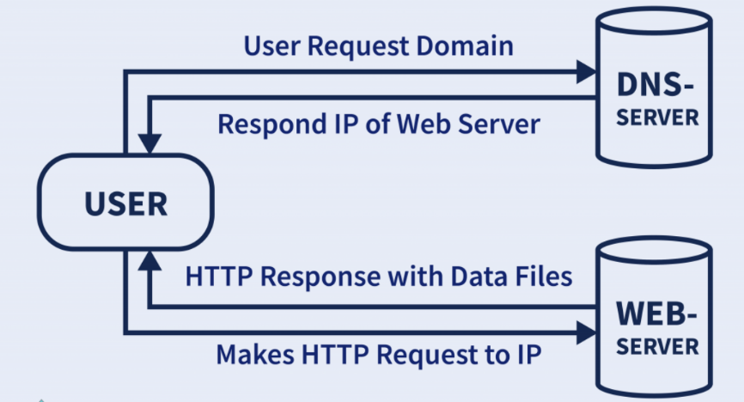
HTTP client-server communication
5. Explain the function of the TCP/IP model and its layers
Ans:- 1. Application Layer:- Provides services directly to the user, such as web browsing and email.
Examples: HTTP, FTP, SMTP
2. Transport Layer:- Ensures reliable data transfer, error checking, and flow control.
Protocols: TCP (reliable), UDP (fast but less reliable)
3. Internet Layer:- Handles logical addressing and routing of data packets across networks.
Protocol: IP
4. Network Access Layer:- Manages the physical transmission of data over hardware like cables and wireless networks.
Examples: Ethernet, Wi-Fi
- Explain Client Server Communication
Ans:- Client:-
A client is a device or application that requests data or services.
- Examples: Web browser, mobile app, email client
Server:-
A server is a system that provides data or services to clients.
- Examples: Web server, database server, file server

LAB EXERCISE: Research different types of internet connections (e.g., broadband, fiber, satellite)and list their pros and cons.
Types of Internet Connections – Pros & Cons
- Broadband (DSL / Cable)
Description:
Uses telephone lines (DSL) or cable TV lines (Cable) to provide internet access. Always on.
Pros:
- Widely available
- Affordable
- Faster than dial-up
- Suitable for home and small offices
Cons:
- Speed decreases with distance (DSL)
- Shared bandwidth (Cable)
- Slower than fiber

- Fiber-Optic Internet
Description:
Uses fiber-optic cables to transmit data as light signals.
Pros:
- Very high speed (up to Gbps)
- Low latency
- Reliable and stable
- Best for streaming, gaming, cloud work
Cons:
- Expensive installation
- Limited availability in rural areas

- Satellite Internet
Description:
Uses satellites in space to provide internet, mainly in remote areas.
Pros:
- Available in rural and remote locations
- No need for cables
- Wide coverage
Cons:
- High latency (delay)
- Affected by weather
- Expensive
- Not ideal for gaming or video calls

- Mobile Internet (4G / 5G)
Description:
Uses cellular networks to provide wireless internet via SIM cards.
Pros:
- Portable
- Easy to set up
- Good speeds with 4G/5G
- Ideal for smartphones and hotspots
Cons:
- Data limits
- Speed varies with signal strength
- Can be costly for heavy usage

- Dial-Up Internet
Description:
Uses telephone lines and modems to connect.
Pros:
- Low cost
- Available where no broadband exists
Cons:
- Very slow
- Cannot use phone and internet together
- Outdated technology

- Wireless (Wi-Fi / Fixed Wireless)
Description:
Internet provided through radio signals from towers.
Pros:
- No physical cables
- Quick installation
- Good for rural areas
Cons:
- Signal interference
- Weather impact
- Speed depends on distance
- Explain Client Server Communication Types of Internet Connections.
Ans:- Client–server communication:-
Client–server communication is a model where a client (browser or app) sends a request to a server for data or services.
The server processes the request and sends a response back to the client.
Steps:-
- Client sends a request (e.g., open a website).
- Server receives and processes the request.
- Server sends data or results to the client.
- Client displays the response to the user.
Internet Connections:-
- Dial-up Connection:- Uses telephone lines, very slow.
- DSL (Digital Subscriber Line):-Faster than dial-up, uses phone lines.
- Cable Internet:- Uses cable TV lines, high speed.
- Fiber Optic:- Very high speed using optical fibers.
- Mobile Data (3G/4G/5G):- Internet through mobile networks.
- Satellite Internet:- Uses satellites, useful in remote areas.
- Wi-Fi / Wireless:- Connects devices wirelessly to the internet.

- How does broadband different from fiber-optic internet protocols?
Ans:-
Broadband Internet | Fiber-Optic Internet
Uses copper cables(DSL or cable ) | Uses optical fiber cables
Speed is moderate | Very high speed
More signal loss over distance | Very low signal loss
Lower cost | Higher cost
Download speed usually higher than upload. | Upload and download speeds are almost equal.

LAB EXERCISE:-Simulate HTTP and FTP requests using command line tools (e.g., curl).
Ans:-HTTP Requests: Used to interact with web servers (GET, POST, headers).
• FTP Requests: Used to transfer files to/from servers.
• Command-line tools like curl are simple and effective for testing and debugging network requests.

- What are the differences between HTTP and HTTPS protocols?
Ans:-
HTTP | HTTPS
Stands for Hyper Text Transfer Protocol. | Stands for Hyper Text Transfer Protocol Secure.
Data is not encrypted. | Data is encrypted.
Less secure. | More Secure.
Vulnerable to hacking. | Protected against data theft.
Uses port 80. | Uses port 443.
No SSL/TLS certificate. | Uses SSL/TLS certificate

LAB EXERCISE:- Identify and explain three common application security vulnerabilities. Suggest possible solutions
Ans:- Application security vulnerabilities like SQL injection, Cross-Site Scripting (XSS), and weak authentication can compromise data and user trust. Proper input validation, secure coding practices, and authentication measures are essential to protect applications.

- What is the role of encryption in securing applications Software Applications and Its Types.
Ans:- 1. Desktop Applications:- Installed on a computer (e.g.,MS Word).
2. Web Applications:- Run in a web browser (e.g., Gmail).
3. Mobile Applications:- Designed for smartphones (E.gWhatsApp)
4. Enterprise Applications:- Used by organizations (e.g.,ERP Systems).
LAB EXERCISE: Identify and classify 5 applications you use daily as either system software or application software.
Ans:-
Software | Type | Reason
Windows 10 | System Software | Manages hardware, provides platform for other applications
Google Chrome | Application Software | Used for browsing the internet, performing user tasks
Microsoft Word | Application Software | Used for creating and editing documents
Antivirus (Windows Defender) | System / Utility Software | Protects system from malware and performs maintenance
VS Code | Application Software | Used for coding and software development tasks

11. What is the difference between system software and application software?
Ans:-
System Software | Application Software
System software manages and controls the computer hardware. | Application software helps users perform specific tasks.
It acts as an interface between hardware and the user. | It acts as an interface between the user and the system software.
It is essential for the computer to run. | It is not essential for basic system operation.
It starts running when the computer is powered on. | It runs only when the user starts it.
Usually runs in the background. | Usually runs in the foreground.

LAB EXERCISE: Design a basic three-tier software architecture diagram for a web application
Ans:- Scalable – each layer can be scaled independently
Secure – database is not directly accessible by users
Maintainable – easy to update or modify layers
Reusability – business logic can serve multiple clients

12.What is the significance of modularity in software architecture?
Ans: It improves maintainability, reusability, scalability, and testability, makes the system easier to understand, allows parallel development, and enables changes in one module without affecting the entire system.
LAB EXERCISE: Create a case study on the functionality of the presentation, business logic, and data access layers of a given software system.
- Ans:- Presentation Layer: Interfaces with users
- Business Logic Layer: Processes user requests and enforces rules
- Data Access Layer: Manages data storage and retrieval
Together, these layers ensure a scalable, maintainable, and reliable software system, separating concerns for better functionality and easier maintenance.
13. Why are layers important in software architecture?
Ans:-Layers are important in software architecture because they separate responsibilities within a system. This separation improves maintainability, scalability, and flexibility, makes the system easier to understand and test, and allows changes in one layer without affecting others.
LAB EXERCISE: Explore different types of software environments (development, testing, production).Set up a basic environment in a virtual machine.
Ans:- Using separate environments (development, testing, production) improves software reliability. Virtual machines provide isolated setups for development or testing without affecting your main system.

14. Explain the importance of a development environment in software production.
Ans:- A development environment is important in software production because it provides the necessary tools, frameworks, and configurations to build, test, and debug software efficiently. It helps developers write consistent code, find errors early, improve productivity, and ensure the software works correctly before deployment.
LAB EXERCISE: Write and upload your first source code file to Github.
Ans:- I created a simple source code file (hello.js) containing a Hello World program.
I then created a GitHub repository and uploaded the file using Git, making my first successful source code upload to GitHub.

15. What is the difference between source code and machine code?
Ans:- Source Code
- Written by programmers using high-level languages (e.g., C, Java, Python).
- Easy for humans to read and understand.
- Must be compiled or interpreted to run on a computer.
Machine Code
- Written in binary (0s and 1s).
- Directly understood and executed by the computer’s CPU.
- Generated from source code after compilation or interpretation.
LAB EXERCISE: Create a Github repository and document how to commit and push code changes.
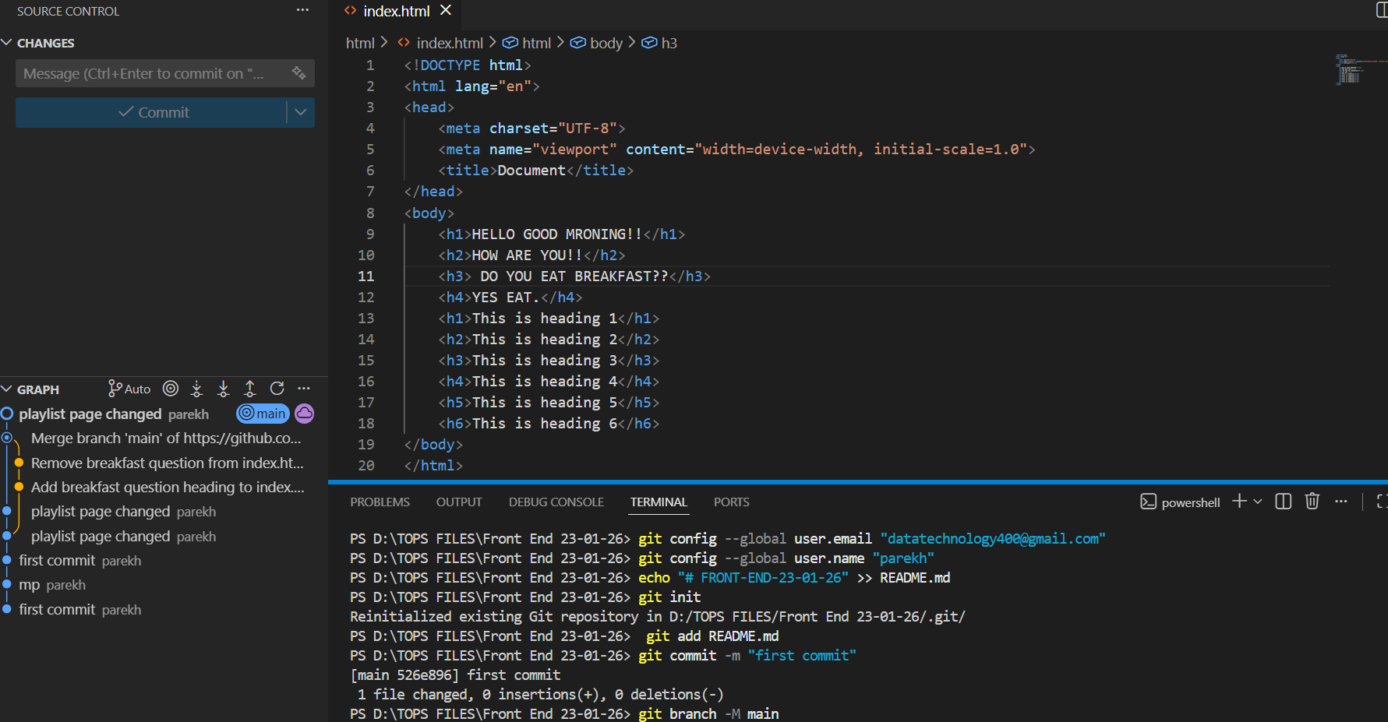

16. Why is version control important in software development?
Ans:- Version control is important in software development because it helps track and manage changes to code over time. It enables team collaboration without conflicts, allows developers to revert to earlier versions if errors occur, maintains a history of modifications, and improves code quality, stability, and project management.
LAB EXERCISE: Create a student account on Github and collaborate on a small project with a classmate.
17. What are the benefits of using Github for students?
Ans:-
- Helps learn version control (Git), an essential industry skill.
- Enables easy collaboration on group projects.
- Provides a portfolio to showcase projects to recruiters.
- Tracks code changes and allows rollback if mistakes occur.
- Access to open-source projects for learning and contribution.
- Offers GitHub Student Developer Pack with free tools and resources.
LAB EXERCISE: Create a list of software you use regularly and classify them into the following categories: system, application, and utility software.
Ans:- 1️⃣ System Software
- Windows 10
- Linux
- macOS
2️⃣ Application Software
- Google Chrome
- Microsoft Word
- VS Code
- WhatsApp
- Adobe Photoshop

3️⃣ Utility Software
- Windows Defender
- Disk Cleanup
- CCleaner
- WinRAR
- Backup & Restore
18. What are the differences between open-source and proprietary software?
Ans:-
Aspect | Open-Source Software | Proprietary Software
Source Code | Publicly available | Not available to users
Modification | Users can modify and customize | Modification not allowed
Cost | Usually free | Usually paid
License | Open licenses (e.g., GPL, MIT) | Restricted commercial licenses
Transparency | High transparency | Low transparency

LAB EXERCISE: Follow a GIT tutorial to practice cloning, branching, and merging repositories
Ans:- Git cloning copies repositories, branching allows parallel development, and merging integrates changes safely into the main codebase.

19. How does GIT improve collaboration in a software development team?
Ans:- Git improves collaboration in a software development team by allowing multiple developers to work on the same project simultaneously. It manages code changes through branches, tracks who made what changes, helps merge work safely, resolves conflicts, and maintains a complete history of the project, ensuring smooth and efficient teamwork.
LAB EXERCISE: Write a report on the various types of application software and how they improve productivity.
Ans:- Types of Application Software
1️⃣ Office Productivity Software
- Examples: MS Word, Excel, PowerPoint
- Improves document creation, data analysis, and presentations.
2️⃣ Communication Software
- Examples: Email, Zoom, WhatsApp
- Enables fast communication and collaboration.
3️⃣ Web Browsers
- Examples: Google Chrome, Firefox
- Provides quick access to information and online tools.
4️⃣ Design & Multimedia Software
- Examples: Photoshop, Canva
- Enhances creativity and visual content creation.
5️⃣ Development Software
- Examples: VS Code, Eclipse
- Helps developers write, test, and debug code efficiently.
6️⃣ Business & Accounting Software
- Examples: Tally, QuickBooks
- Automates financial tasks and record management.
20. What is the role of application software in businesses?
Ans:- Application software plays a key role in businesses by helping perform specific tasks efficiently. It supports operations like accounting, payroll, inventory management, customer relationship management (CRM), communication, data analysis, and reporting, which improves productivity, accuracy, decision-making, and overall business performance.
LAB EXERCISE: Create a flowchart representing the Software Development Life Cycle (SDLC)
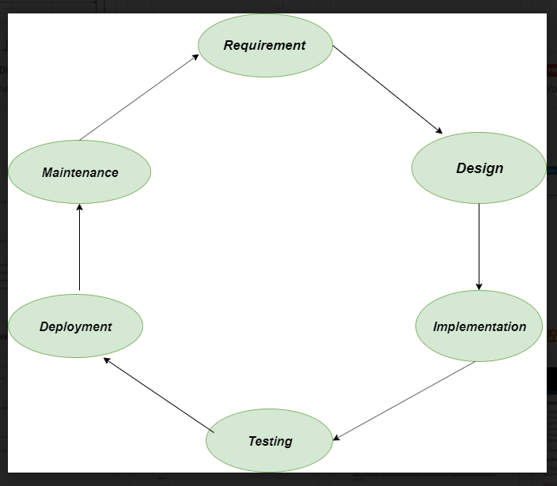

21. What are the main stages of the software development process?
Ans:-
- Requirement Analysis:- Understanding user needs and system requirements
- Design:- Planning the software structure and architecture
- Development (Coding):- Writing the program code
- Testing:- Finding and fixing errors
- Deployment:- Releasing the software for use
- Maintenance:- Updating and improving the software after release
LAB EXERCISE: Write a requirement specification for a simple library management system.
Ans:- System Name: Library Management System
Objective:
To manage library operations such as book records, member details, and book issue/return efficiently.

Functional Requirements
- Add, update, and delete book information
- Register and manage library members
- Issue and return books
- Search books by title, author, or ID
- Maintain issue and return records

Non-Functional Requirements
- User-friendly interface
- Secure login for librarian
- Fast search and response time
- Data accuracy and reliability

Hardware Requirements
- Computer system
- Keyboard and mouse

Software Requirements
- Operating System: Windows / Linux
- Database: MySQL
- Programming Language: Java / Python

22. Why is the requirement analysis phase critical in software development?
Ans:- The requirement analysis phase is critical because it defines what the software must do. Clear and accurate requirements prevent misunderstandings, reduce costly errors later, guide design and development, ensure the final product meets user needs, and form the basis for testing and project planning.
LAB EXERCISE: Perform a functional analysis for an online shopping system.
Ans:- System Name: Online Shopping System
Objective:
To allow users to browse products, place orders, and make online payments efficiently.

Main Functions
1️⃣ User Management
- User registration and login
- Profile management
2️⃣ Product Management
- Display product catalog
- Search and filter products
- View product details
3️⃣ Shopping Cart
- Add and remove products
- Update product quantities
4️⃣ Order Processing
- Place orders
- Generate order confirmation
5️⃣ Payment System
- Online payment processing
- Payment status confirmation
6️⃣ Order Tracking
- View order status
- Order history

23. What is the role of software analysis in the development process?
Ans:- Software analysis plays a crucial role in the development process by understanding and defining the problem the software needs to solve. It involves gathering requirements, studying system needs, identifying constraints, and creating a clear specification. This ensures that developers build the right solution, reduces errors, and guides design, development, and testing effectively.
LAB EXERCISE: Design a basic system architecture for a food delivery app.
Ans:-
| User Interface |
| (Customer / Restaurant / |
| Delivery Partner Apps) |
| |
| - Mobile App (Android/iOS) |
| - Web App |
+--------------▲--------------+
|
| HTTPS / REST API
|
+--------------▼--------------+
| Application Server |
| (Business Logic Layer) |
| |
| - User Authentication |
| - Restaurant Management |
| - Order Management |
| - Payment Processing |
| - Notification Service |
+--------------▲--------------+
|
| API / ORM
|
+--------------▼--------------+
| Database Server |
| (Data Layer) |
| |
| - Users Data |
| - Restaurant & Menu Data |
| - Orders & Payments |
| - Delivery Status |
+--------------▲--------------+
|
| External Services
|
+--------------▼--------------+
| Third-Party Services |
| |
| - Payment Gateway |
| - Maps & GPS Service |
| - SMS / Email Notifications |

24. What are the key elements of system design?
Ans:- Architecture Design – Defines the overall structure and components of the system.
- Interface Design – Specifies how users and components interact with the system.
- Data Design – Organizes how data is stored, accessed, and managed.
- Component Design – Details the internal logic and functionality of each module.
- Security Design – Ensures the system is protected from threats and unauthorized access.
- Performance Design – Optimizes the system for speed, scalability, and efficiency.
LAB EXERCISE: Develop test cases for a simple calculator program.
Ans:-
Test Case ID | Test Description | Input | Operation | Expected Output
TC01 | Add two positive numbers | 10, 5 | Addition (+) | 15
TC02 | Subtract two numbers | 10, 5 | Subtraction (−) | 5
TC03 | Multiply two numbers | 4, 6 | Multiplication (×) | 24
TC04 | Divide two numbers | 20, 4 | Division (÷) | 5
TC05 | Add negative numbers | −3, −2 | Addition (+) | −5
TC06 | Divide by zero | 10, 0 | Division (÷) | Error message
TC07 | Add zero to a number | 8, 0 | Addition (+) | 8
TC08 | Decimal number calculation | 2.5, 1.5 | Addition (+) | 4.0

25. Why is software testing important?
Ans:- Software testing is important because it ensures that the software works correctly, meets user requirements, and is free of defects. It helps identify and fix errors early, improves quality, reliability, and performance, reduces maintenance costs, and ensures a better user experience.
LAB EXERCISE: Document a real-world case where a software application required critical maintenance.
Ans:- Case: Banking Mobile Application
ProblemIdentified:
A major bank’s mobile banking app faced frequent crashes and transaction failures after a system update, causing users to be unable to transfer money or check balances.

Type of Maintenance Required
- Corrective Maintenance: Fixing bugs causing app crashes
- Adaptive Maintenance: Updating the app to support new OS versions
- Preventive Maintenance: Improving system stability to avoid future failures

Actions Taken
- Identified and fixed software bugs
- Released an emergency patch update
- Improved server load handling
- Enhanced security checks

Outcome
- App stability was restored
- Transactions processed successfully
- Customer trust and service reliability improved

26. What types of software maintenance are there?
Ans:-
- Corrective Maintenance : Fixing bugs or errors found after deployment.
- Adaptive Maintenance: Updating the software to work with new environments, hardware, or operating systems.
- Perfective Maintenance: Enhancing performance, adding features, or improving usability.
- Preventive Maintenance: Making changes to prevent future problems and improve software reliability.
LAB EXERCISE: Create a DFD for a hospital management system
- Ans:- Patient Registration: Stores patient personal details
- Appointment Management: Schedules doctor appointments
- Treatment & Diagnosis: Maintains medical records
- Billing System: Generates bills for treatments
- Doctor Records: Stores doctor information

27. What are the key differences between web and desktop applications?
Ans:-
Aspect | Web Applications | Desktop Applications
Access | Runs in a web browser via the internet | Installed and runs locally on a computer
Platform Dependency | Platform-independent (works on any device with a browser) | Platform-dependent (may require specific OS)
Installation | No installation needed | Must be installed on each device
Updates | Updated centrally on the server | Updates must be installed individually on each device
Connectivity | Usually requires internet | Can work offline (mostly)
Maintenance | Easier to maintain and deploy | Maintenance can be more complex and time-consuming

LAB EXERCISE: Build a simple desktop calculator application using a GUI library.
Ans:- This lab exercise demonstrates how to build a desktop calculator using Python Tkinter, integrating GUI elements and event handling for basic arithmetic operations.
28.What are the advantages of using web applications over desktop applications?
Ans:-
- Platform Independence – Can run on any device with a web browser.
- No Installation Needed – Users can access them directly online.
- Easy Updates – Updates are done on the server; users always access the latest version.
- Accessibility – Can be used anywhere with an internet connection.
- Lower Maintenance – Centralized management reduces support and maintenance effort.
- Collaboration – Multiple users can access and work on the app simultaneously.
LAB EXERCISE: Draw a flowchart representing the logic of a basic online registration system.
Ans:-
• Start: Begin the registration process.
• Display Registration Form: Show form to the user.
• Enter User Details: Collect Name, Email, Password.
• Validate Input Data: Ensure fields are not empty and password meets criteria.
• Check Email: Prevent duplicate accounts.
• Save Data: Store user details in the database.
• Registration Successful: Confirm to the user.
• End: Complete the process.

29. What are the differences between native and hybrid mobile apps?
Ans:-
Aspect | Native Apps | Hybrid Apps
Development | Built for a specific platform (iOS, Android) using platform-specific languages (Swift, Kotlin) | Built using web technologies (HTML, CSS, JavaScript) and wrapped in a native container
Performance | High-performance-and smooth user experience | Lower-performance compared to native apps
Access to Device Features | Full access to device hardware and features | Limited access, though plugins can extend functionality
Development Cost | Higher cost (separate code for each platform) | Lower cost (single codebase for multiple platforms)
Maintenance | Updates must be made separately for each platform | Easier to maintain due to shared codebase
User Experience | Better UI/UX, tailored to the platform | UI/UX may feel less native and consistent across platforms

30. What is the significance of DFDs in system analysis?
Ans:-
- Visualizes the System:- Shows how data flows between processes, inputs, and outputs.
- Simplifies Complexity:-Breaks down complex systems into understandable components.
- Identifies Processes and Data Stores:- Helps in understanding what the system does and where data is stored.
- Improves Communication:- Provides a clear diagram for analysts, developers, and stakeholders.
- Aids in System Design:- Serves as a blueprint for creating or improving the system.
31. What are the pros and cons of desktop applications compared to web applications?
Ans:-
- Pros of Desktop Applications:
- Better Performance – Runs locally, so faster and more responsive.
- Offline Access – Can work without an internet connection.
- Full Hardware Access – Can utilize all system resources and hardware features.
- Enhanced Security – Data stays on the user’s device.
- Cons of Desktop Applications:
- Platform Dependent – Needs separate versions for Windows, macOS, etc.
- Installation Required – Must be installed on every device.
- Difficult Updates – Each device must be updated individually.
- Limited Accessibility – Can only be used on the installed device.
32. How do flowcharts help in programming and system design?
Ans:- Flowcharts help in programming and system design by visually representing the step-by-step flow of logic and processes. They make complex logic easier to understand, help identify errors early, improve communication among team members, and serve as a clear guide for coding and system implementation.

